# Introduction

To connect to PC2 using a browser, enter the URL of the PC2 *Web Team Interface* (WTI) into the address bar of your browser (the correct URL information can be obtained from the Contest Director). When connected to the PC2 WTI, the following *Login* screen will appear:

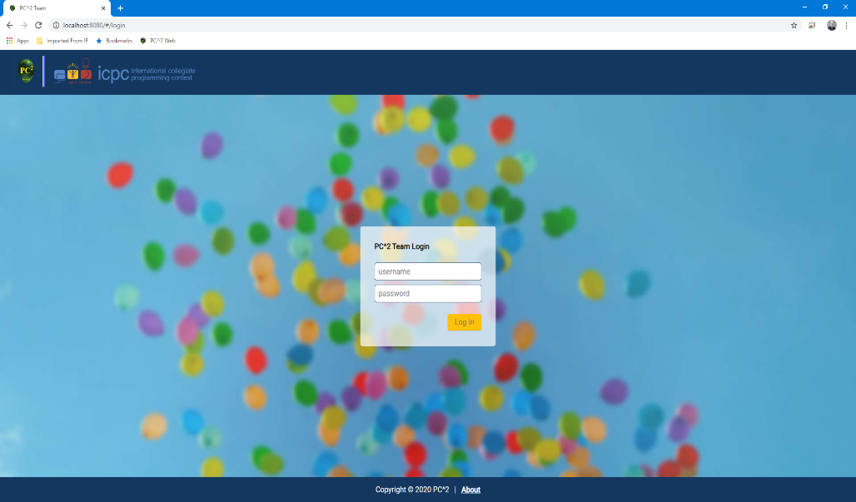

To login to PC2:

* Click on the **Username** box and enter your assigned team ID.
  + Your team ID will be of the form teamXX, where XX is your assigned team number. For example: “team2” or “team15”
* Click on the **Password** box and enter your assigned password.
* Click on the **Login** button.

Successfully logging in will display the following screen (called the **Runs** screen):

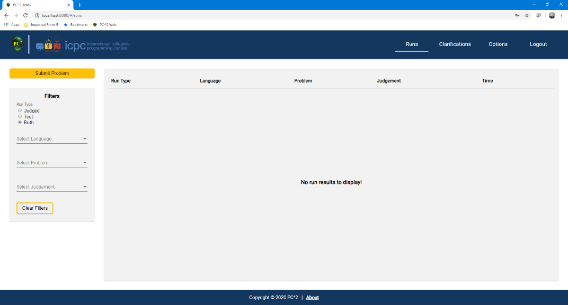

# Submitting a Problem for Judging

To submit a problem to be judged:

* Click on the **Runs** tab at the top right on the page (if not already on the **Runs** page).
* 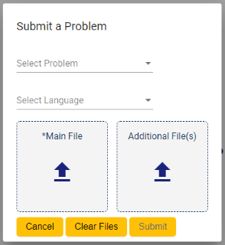Click on the **Submit Problem** button in the upper left hand corner of the **Runs** page. A pop-up with the title “Submit a Problem” will display, as shown:
* Select the problem for which you are submitting a solution from the drop down list titled **Select Problem**.
* Select the language that the solution you are submitting uses from the drop down list titled **Select Language**.
* Select the main file that contains your solution. To do this, click on the  symbol in the box titled **Main File**. This will display a file dialog which will allow you to locate and select your main file. Select only source code files for submission (do not submit data files or executable files).
* If additional source code files are needed for your solution, you can click on the  in the box titled **Additional File(s)**. This will display another file dialog which will allow you to locate and select your additional file(s).
* To remove the currently-selected files from the **Main File** and **Additional File(s)** list, click the **Clear Files** button.
* Once you have made the desired selections, click the **Submit** button to submit your solution to be judged. Note: your submission must include at least a selected problem, a selected language, and a selected main file. The **Submit** button will be disabled until these items have all been selected.
* If you decide that you do not want to submit your solution at this time, click the **Cancel** button to be returned to the Runs screen.

# Viewing Submission Results

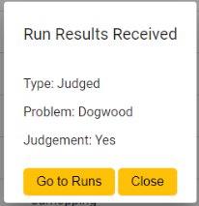When a submission has been judged, the team will receive a “pop-up notification”[1] such as the following:

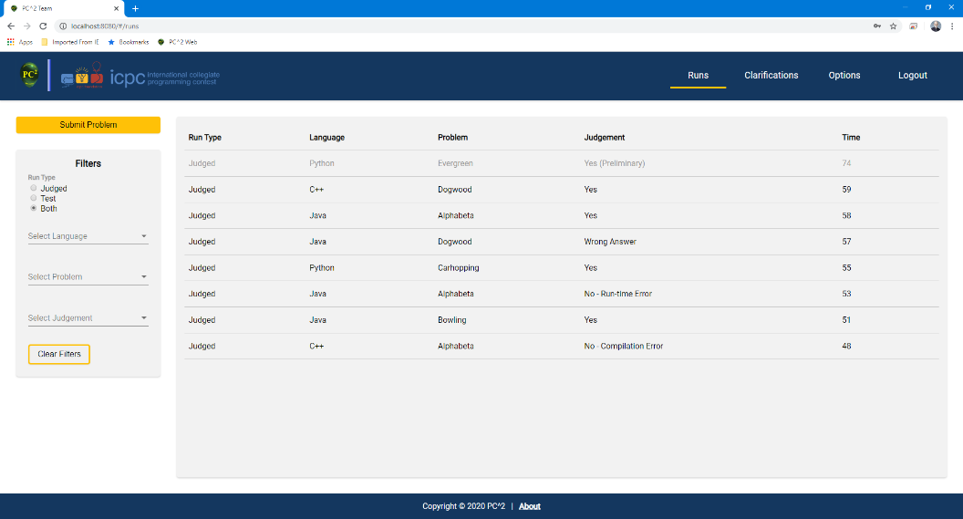To view the status of *all* submissions for your team, click on the **Runs** tab at the top right side of the page. This will display the **Runs** page, which will look something like the following:

* The **Runs** page contains a table that displays all submissions. Submission information includes the **Run Type** (currently, the only supported type is **Judged**), the **Language** the solution was done in, the **Problem** the solution was submitted for, the **Judgement** received for the submission, and the **Time** the run was submitted. If the judgement is *Preliminary* (see below) it will labeled as such in the table.
* There are four ***filters*** that can be used to filter (limit) the submissions being displayed in the **Runs** table: *Run Type, Language, Problem, and Judgement.*
  + Filtering by **Run Type**:
    - If you want to view *only runs submitted for judging*, click on the **Judged** radio button under the run type filter heading.
    - If you want to view *only runs submitted for testing*, click on the **Test** radio button under the run type filter heading. (Note: in the current WTI implementation only **Judged** run submissions are supported; therefore if the **Test** Run Type is selected then no submissions will be displayed.)
    - By default (if no run type filter is chosen) or if the **Both** radio button is clicked, all run types will be displayed.
  + Filtering by **Language**:
    - If you want to filter runs to view *only runs submitted for a single language*, click on the **Select Language** drop down list. Select the language you want to filter by.
  + Filtering by **Problem**:
    - If you want to filter runs to view *only runs submitted for a single problem*, click on the **Select Problem** drop down list. Select the problem you want to filter by.
  + Filtering by **Judgement**:
    - If you want to filter runs to view *only runs submitted for a single judgement*, click on the **Select Judgement** drop down list. Select the judgement you want to filter by.
  + Filters can be used in combination. To clear all filter selections, click the **Clear Filters** button.
* Preliminary Judgements:

The Contest Director may choose to configure PC2 to judge problems either automatically (“by computer”, a process called *AutoJudging*), or manually (by human judges), or both.

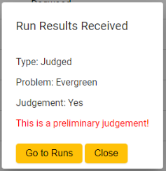If a problem is being judged both manually *and* using AutoJudging, the system will return the AutoJudging result to the team as soon as it is finished. This judgement is termed a *Preliminary Judgement* and will be so-labeled in the **Runs** table (see above). The Run Result pop-up notification for Preliminary Judgements (if not disabled) will display an appropriate “Preliminary Judgement” notice in red font, as shown below:

When the judges manually check the submission result and choose a final judgement, the team will receive another notification of the Final Judgement.

# Clarifications

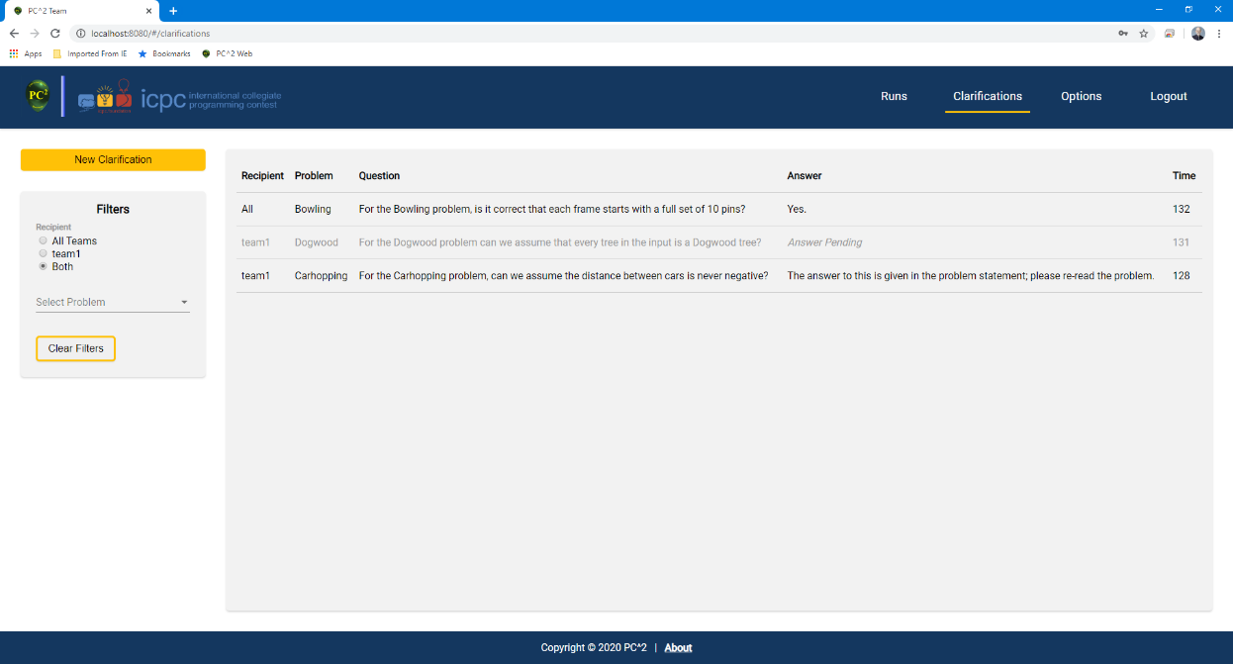To request a clarification on a problem, click on the **Clarifications** tab at the top right of the page. This will display the **Clarifications** page, which will look something like this:

The Clarifications page displays all clarification requests previously submitted by your team. It also displays clarifications that the judges have chosen to send to all teams. If a clarification request has been answered, the answer also appears in the Clarifications table.

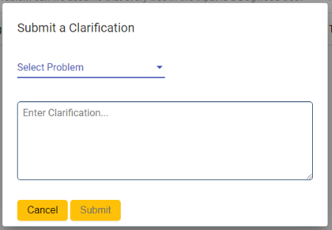To request a ***new*** clarification, click on the **New Clarification** button in the upper left hand corner of the **Clarifications** page. A pop-up will display with the title “Submit a Clarification”, a shown:

* Select the problem for which you are submitting a clarification request using the **Select Problem** drop down list.
* Enter your clarification request into the text box. Only plain text is allowed.
* Click the **Submit** button. A clarification must have a problem selected and text entered into the text box in order to be submitted.

*Please note that while the contest judges will consider requests for clarification of ambiguities in a problem statement, they will not normally respond to other types of questions. If you submit a clarification which asks about something that the judges feel is adequately covered in the problem statement, they may simply respond to your clarification with an answer such as “No response; Read the problem statement”.*

* There are two ***filters*** that can be used to filter (limit) the clarifications being displayed in the clarifications table: *recipient and problem.*
  + Filtering by **Recipient**:
    - If you want to filter clarifications to view *only clarifications intended for All Teams*, click on the **All Teams** radio button under the recipient filter heading.
    - If you want to filter clarifications to view *only clarifications intended for only your team*, click on the radio button **labeled with your team name** under the recipient filter heading.
    - By default (if no recipient type filter is chosen) or if the **Both** radio button is clicked, all recipient types will be displayed.
  + Filtering by **Problem**:
    - If you want to filter clarifications to view *only clarifications submitted for a single problem*, click on the **Select Problem** drop down list. Select the problem you want to filter by.

# Options

There are two WTI configuration options: changing your team login password and enabling/disabling certain pop-ups. *These options are at the discretion of the contest administrator, and may or may not be available for your contest.*

To select from available options, click on the **Options** tab at the top right side of the page. This will display the **Options** page, shown below:

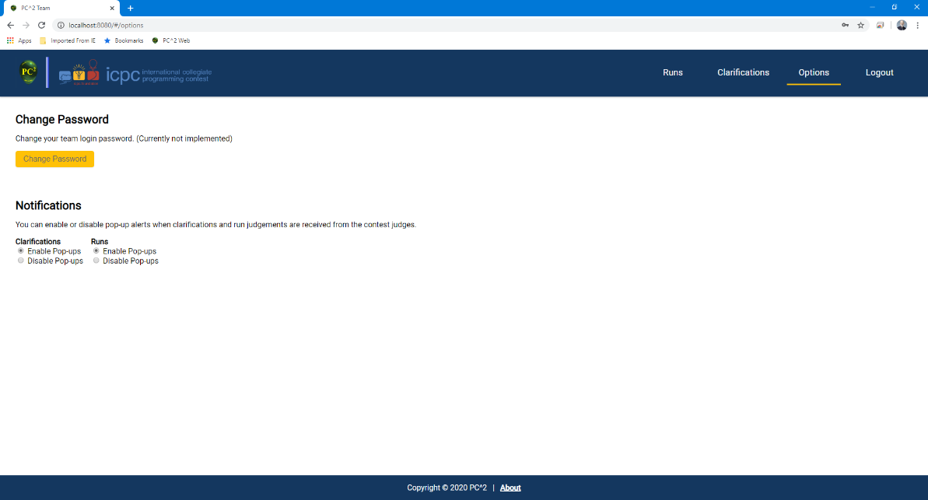

To change your team login password:

* Click on the **Change Password** button located on the left side of the options screen.
* A pop-up will display with the title Change Password.
* Click on the **Current Password** box and enter your current team password.
* Click on the **New Password** box and enter the new password you want for your team login credentials.
* Click on the **Re-enter New Password** box and enter the new password you want again.
* Click on the **Submit** button.
* If you do not want to change your password, click the **Cancel** button to be returned to the options screen.

To enable/disable certain pop-ups:

* To enable pop-ups, click on the **Enable Pop-ups** radio button.
* To disable pop-ups, click on the **Disable Pop-ups** radio button.

# Logging Out

To logout from PC2, click the **Logout** tab at the top right side of the page. This will return you to the **Login** page.

# About Information

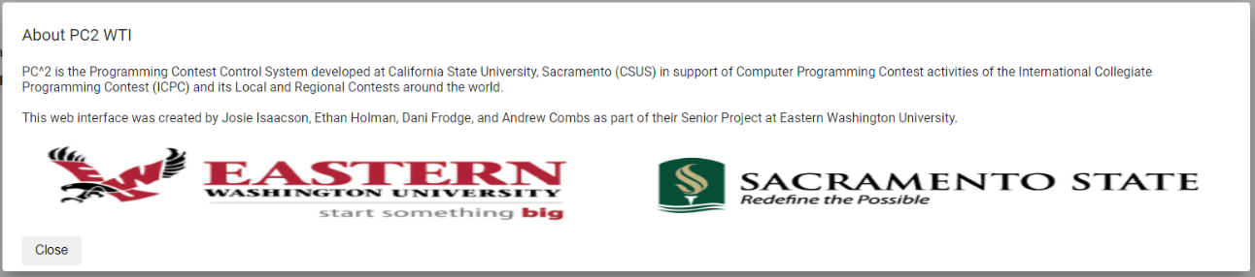To view information about PC2, click on the **About** link available at the bottom of any page. A pop-up will be displayed with information about PC2 and its creators, similar to the following:

* To exit, click the **Close** button in the lower left hand corner of the pop-up. You will be returned to the page you were on prior to clicking the **About** link.

1. Pop-ups like this can be disabled if desired; see **Options** below.